I. INTRODUCTION

Time table scheduling is one of the most important and time-taking task done in institutional administration now a days. The physical time table generation requires a lot of time and effort. The problem increases when the constraints or the amount of data to deal with increases.

Genetic Time-Table generator is an AI based software which is used to generate time table automatically. It can take all the constraints which are required to generate a time table. It can further take care of the work load assigned to each faculty. It is a complete time table generator for college which can satisfy both the hard and soft constraints.

The software resolves the problem by assigning every subject to a suitable teacher. Angular is used in the front-end which makes a user-friendly interface and Java and MySQL are used in back-end. AI(genetic algorithms) is used to satisfy the soft constraints to the software. It helps in finding a balance in the work load of all the faculty members and students.

Moreover, this software offers a concept of ‘freezing’ the time table of some teachers. It is particularly useful when some teachers are satisfied with the given time table and some are not. The satisfied faculty members can freeze their time-table and the timetables of those teachers who have not freeze will be generated again based on available slots and constraints.

The time table generator allocates the resources in most efficient way possible. Most educational institutes have different courses and each course offers a different set of subjects. Now, the genetic time table scheduler assigns the faculty at the suitable time slot such that there is no overlapping in timetable of students, teachers and rooms.

EXISTING SYSTEMS

Most institutes create the time table manually. Although managing and maintaining the timetable manually is possible but considering the workload of teachers is a complex process.

A lot of methods exist to solve the time table generation problem such as:-

i. graph coloring
ii. simulated annealing
iii. Tabu search

PROPOSED SYSTEM

Proposed System will help to manage all the lectures automatically which will save a lot of time and resources. The teachers will not have to worry about their workload as Genetic Algorithm used here will take care of the workloads of all the teachers and students. Moreover, if a teacher is not satisfied with his/her timetable, there is always an option of not freezing the timetable which can generate new time table based on available slots and constraints.

Inputs Required :
i. Teachers List along with the subjects they are supposed to teach
ii. Course List along with the details of each course like course code, teaching hours per week, etc.
iii. University Central Data such as details of elective courses offered, etc.

The proposed system is a website which allows teachers to input their data in a friendly interface. When all the teachers have inserted the data, time table generator creates schedules for all the faculty members, sections and rooms.

The security feature is also present in the software where the records can only be updated by admin or the concerned faculty member by his/her login credentials.

Technologies used :- Angular, Java Spring, MySQL

HARD CONSTRAINTS

Hard constraints are those constraints which have to be satisfied in order to produce a solution.

i. No teacher can teach more than 1 class at a time.
ii. No section can have more than 1 lecture at a time.
iii. No room can accommodate multiple lectures at a single time slot.

SOFT CONSTRAINTS

Soft constraints are those which are not necessary in order to get a solution but they are given high importance when a solution is created for real life.

i. No teacher can have continuous lectures for 3 hours.
ii. Every section will have break of at least 1 hour in a day.
iii. No section will study the same subject for more than 2 hours a day.
iv. Teacher timetable will be distributed uni formally within the week.

Generally soft constraints cannot be satisfied for all the teachers and sections at the same time. The idea is to create a balance between the workload of teachers and to satisfy the mentioned soft constraints as much as possible.

In order to create a time table with the soft constraints satisfied as much as possible, genetic algorithm is used.

Basic terms used in generic algorithms:

i. crossover: Combines parents to form children for next generation.

ii. mutation: Apply changes to a single parent to form childern

iii. Fitness functions:

iv. Heuristics:

IMPLEMENTATION

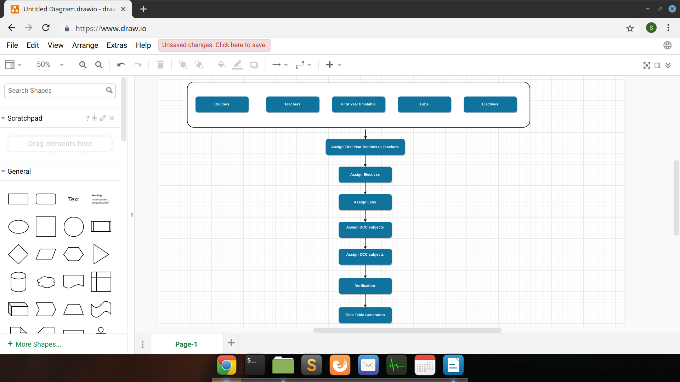

The software has 3 major parts:-
i. Inserting data
ii. Assigning lectures to teachers and students
iii. Display the timetables of students, teachers and rooms

i. Inserting data

faculty details:- Various details of faculty members are inserted like subjects they are teaching and if they are unavailable in some slots of a particular day, they can also mention it.

Central Timetable details:- Details for the central generated time table are mentioned here which includes details of elective and the time time of first year students.

ii. Assigning lectures to teachers and students

In this section, all the teachers and sections are assigned to their respective subjects. Various hard constraints are checked like overlapping of teachers or sections. If some teacher has blocked a slot in his/her timetable, the slot won’t be assigned to her.

iii. Display timetables of students, teachers and rooms

After assigning of lectures is completed, we can view timetables of teachers, students and rooms.

Methodology

Methodology is an approach to create a plan by defining methods and guiding principles.
Following methodologies are used here:

i. The timetable of all the faculty members should be distributed uniformly in the week.
ii. No teacher should be assigned more than 2 or 3 hours of theory classes in a day.
iii. If a teacher is assigned only 2 hours or less of theory classes in a day, then he/she can be assigned to a lab.
iv. All sections should have at least 1 hour break in a day.
v. All the professors, associate professors and assistant professor should be given sufficient lectures according to their workload.

CONCLUSION

Timetables for teachers, sections and rooms are generated by this software. Teachers have the option of blocking some slots in which they are unavailable. This system significantly reduces the time and effort required to generate timetable for every teacher, section and room manually.
All the hard-constraints are satisfied while generating each and every timetable. Genetic Algorithm is applied to maximize the application of soft constraints in every time table.
The freezing slot is further used to give teachers an additional feature of blocking some slots in a week in which they are unavailable.
The developed software is user-friendly, fast and reduces time and effort.

Todo:- pictures(software screenshots)

